2024-2025 Concussion Protocol

Recommendations from Own the Podium:

- All high-risk Olympic Winter and Summer NSOs must have an up-to-date sport concussion policy and protocol in place that is, at a minimum, compliant with Rowan’s Law, which specifically addresses:
  - Concussion education/awareness
  - Code of conduct
  - Removal from sport
  - Return to sport

*High-risk Olympic Winter Sports: Alpine Skiing, Freestyle Skiing, Ski jumping, Snowboard, Speed Skating – Short and Long Track, Figure Skating, Ice Hockey, Bobsleigh, Skeleton, Luge

- During the pre-season period and prior to the first day of competitive season training camp, we suggest all high-risk sport athletes undergo:
  - Biographical information assessment, including detailed past medical history such as previous concussion and neck injuries, description of recovery from previous concussions, neurological conditions, psychological/psychiatric conditions, other potential co-morbidities, medications, supplements, alcohol use, recreational drug use, etc.
  - Sport Concussion Assessment Tool (SCAT5), including gat and balance assessment (e.g. BESS/modified BESS)
  - Vestibular/Oculomotor Assessment (e.g. Visual Acuity, King-Devick, VOMS)

- Recognition, diagnosis and timely clinical assessment of suspected concussions may help facilitate earlier recovery, reduce the risk of early complications and avoid further head and musculoskeletal injuries
- If a concussion is suspected (e.g., significant impact to the head, face, neck, or body and demonstrates any of the visual signs/behaviors of a suspected concussion or reports any symptoms of a suspected concussion), the athlete must be removed 4 from training / competition and evaluated immediately.
- In the event of a fall, crash, head contact, or other impulsive force transmitted to the head:
  - The athlete must report to the medical team for assessment (or event physician if no member of the medical team is present).
  - The medical team should also seek out the athlete.
  - Coaches should report any suspicion of a concussion to the medical team or event physician (if no member of the medical team is present).

  - In the event that the suspected concussion is assessed by a COPSI Network team athletic therapist, physiotherapist or chiropractor, the team physician should also be notified (as soon as possible) to assist with management.
  - In the event that no members of the medical team are available, the athlete must be assessed by a physician as soon as possible. Athletes with a suspected concussion should be escorted by a teammate, coach or responsible adult to a physician. Subsequent follow-up should then be arranged with the team or consulting physician.
  - In the case where athletes are competing out-of-country, follow-up with the team physician may be conducted by telephone, internet, etc., where available. The team physician should also be contacted PRIOR to making travel arrangements to return home.
  - Athletes CANNOT be cleared to return to training/competition by paramedical staff or team coaches.
  - We recommend the diagnosis and acute management follow the principles laid out in the Summary and Agreement Statement of the Fifth International Symposium on Concussion in Sport - Berlin 2016
- We recommend that if the athlete experiences any of the following signs or symptoms (worsening headache, drowsiness or inability to be awakened, inability to recognize people or places, repeated vomiting, unusual behavior (confusion or irritable), seizures (arms and legs jerk uncontrollably), weakness or numbness in arms or legs, unsteadiness on their feet, slurred speech), they go to the nearest hospital emergency department immediately.

- Sideline Assessment
  - Standard emergency management principles must be adhered, with particular attention given to excluding a cervical spine injury, determining the disposition of athlete, and identifying any “Red Flags” listed in the Concussion Recognition Tool 5
  - If an athlete is suspected of sustaining a more severe head or spine injury during a game or practice, an ambulance must be called immediately to transfer the patient to the nearest emergency department for further medical assessment.
  - If there is no concern for a more serious head / spine injury and after the first aid issues have been addressed, all suspected cases of concussion must be removed from the playing field and assessed by the medical team in a distraction-free environment where possible (i.e., medical room with only members of the medical team present).
  - Because of the evolving nature of concussion in the acute phase, athletes suspected to have sustained a concussion after the acute sideline evaluation shall not return to practice or competition on the same day of injury, regardless of the resolution of concussion symptoms. If there is any doubt, sit them out!
- Management
  - If a concussion is formally diagnosed, both physical and cognitive relative rest is advised for the initial 24 - 48 hours post-concussion
    - eases discomfort / symptoms during the acute recovery period
    - promotes recovery by minimizing brain energy demands
    - physical and cognitive rest may include:
      - no resistance training / weight lifting, sport-specific training, cross training, cardiovascular conditioning, intense exertion associated with activities of daily living, etc.
      - no excessive mental tasks including driving, studying, reading, social media streaming, etc.
      - quiet environments
      - minimize exposure to visual and auditory stimulation (computer use, television, texting, video games, night clubs, etc.). Removal of screen use most beneficial in 48 hours and then not effective beyond that
      - removal from potential stressful situations (media attention, interviews, team meetings, etc.)
    - other aspects of acute concussion management that are important to consider include:
      - avoiding alcohol or recreational drug use
      - maintain regularly scheduled fluid intake (hydration), meals and snacking (well-balanced)
      - avoiding sleeping pills (e.g., imovane, restoril, xanax, halcion, etc.), anti-inflammatory medication (e.g., aspirin, ibuprofen, aleve, etc.), narcotics and other analgesics within the first 24-48 hours of concussion, and only use thereafter based on physician recommendations.
  - Encouraged to recommend early (after 24-48 hours) return to PA as tolerated (e.g. Walking or stationary cycling)
  - Individuals can systematically advance their exercise intensity based on the degree of symptom exacerbation experienced during prior bout of aerobic exercise
  - Athletes can continue to advance duration and intensity of PA or prescribed aerobic exercise provided there is no more than mild (increase of no more than 2 points vs the pre-exercise value) and brief (<1 hour) exacerbation of their concussion related symptoms
  - Prescribed sub symptom threshold aerobic exercise within 2-10 days of SRC is effective for reducing the incidence of persisting symptoms after concussion (symptoms > 1 month) and is also effective for facilitating recovery in athletes suffering from symptoms lasting longer than 1 month
  - Sleep disturbance in the 10 days after SRC is associated with an increased risk of persisting symptoms and may warrant evaluation and treatment.
- Return to Sport (RTS)
  - Research is clear that practitioners should avoid prescribing absolute physical and cognitive rest, instead should allow athletes to engage in activities of daily living (including walking) immediately following injury, even during the initial period of 24-48 hours of relative rest
  - Light PA as well as prescribed sub symptom threshold aerobic exercise treatment in a safe and supervised environment can be used therapeutically
  - Athletes may begin Step 1 within 24 hours of injury, with progression through each subsequent step typically taking a minimum of 24 hours
  - Progression through the later RTS strategy (Steps 4-6) should be monitored by an HCP
  - Incremental progression of the cognitive and physical load on the athlete, using the magnitude of symptom exacerbation as a guide, provides the athlete with the opportunity to increased confidence throughout recovery, supporting psychological readiness to return to competitive play and fostering a shared RTS decision-making model
  - Unrestricted RTS following SRC typically occurs within 1 month of injury, with an estimated pooled mean time to RTS of 19.8 days
  - Minimum movement through the protocol is 1 week
  - Medical determination of readiness to return to at-risk activities should occur prior to returning to any activities at risk of contact, collision or fall

- We recommend athletes return to unrestricted training and competition only after the following circumstances have occurred:
  - (1) there is complete resolution of concussion-related symptoms at rest,
  - (2) there is no recurrence of concussion-related symptoms at exertion levels required for unrestricted practice and competition,
  - (3) the athlete’s post-concussion clinical and neuropsychological status has returned to individual baseline levels as judged by the team physician, and the team’s consulting neuropsychologist (if resources available and/or part of comprehensive concussion program).

- The Athlete’s Voice
  - The Scientific Committee deemed it important to include the athlete’s perspective in this consensus process.

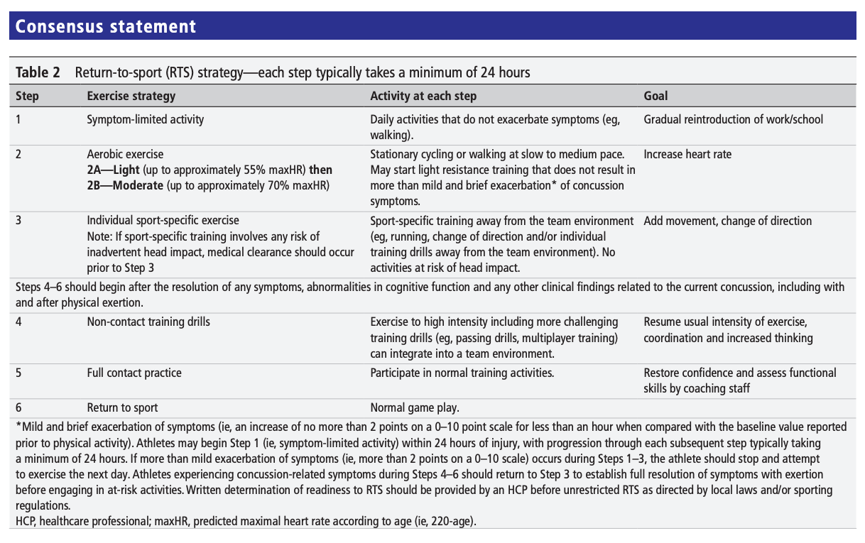

Return to High-Risk Sport following a Sport-Related Concussion

Athlete Informed Consent Acknowledgement Letter

Date: ____________________________________________________________________

Athlete Name: ____________________________________________________________________

Address/City: ____________________________________________________________________

Dear Athlete,

We are pleased that you are making good progress in recovery from your concussion and that you have remained symptom free in all post-concussion testing so far. Your post-injury testing looks good in comparison to your baseline tests. It is now safe for you to return to the sport-specific component of your monitored return to play protocol.

A member of our sport concussion medical team has discussed the risks associated with returning to high-risk sport. You have indicated that despite the risks, it is your desire to return to unrestricted sport participation.

The long-term risk and effects of multiple concussions is something that is difficult to predict. We don’t know how many concussions a person can experience before there may be some permanent impairment. We do know that some individuals never fully recover after one or two concussions, and that others can have multiple concussions each with apparent full recovery. We do know that with each successive concussion, there may be an increased risk that the next concussion may take longer to recover from, or might not result in a full recovery.

In addition to the above, we know that the risk of persistent symptoms, permanent impairment, or in rare circumstances, death, is increased if an individual experiences another concussion before their current concussion has recovered. This is why we go to such great lengths to ensure that your concussion has recovered (to our best clinical ability) before you return to higher risk training or sport competition.

In your individual situation, you have the following features which may place you at higher risk of recurrent injury, prolonged concussion-like symptoms, or incomplete recovery (e.g., decline in cognitive function (thinking / calculating / reasoning)) if you experience another concussion. These features are:

1. You have now had at least _____ documented concussions.
2. ______ of your concussions have had a prolonged recovery (>14 days in adults or >1 month if under 18 years).
By signing this letter, you indicate that you understand that you are returning to a high-risk sport with significant risk and that because of your past concussive history you have personal increased risk, and that you willingly accept that risk. You also acknowledge that you were given the opportunity to ask questions and that all of your questions (if any) were satisfactorily answered.

Sincerely,

IST Medical Lead

Medical Team Representative: ___________________________________________

Medical Team Signature: ________________________________________________

Athlete Name: ____________________________________________

Athlete Signature: _________________________________________

Parent / Guardian Name (if under 18 years): _______________________

Parent / Guardian Signature: ______________________________________

Immediate Assessment

